**Introduction to python**

**Python** is a general-purpose interpreted, interactive, object-oriented, and high-level programming language. It was created by Guido van Rossum during 1985- 1990. Like Perl

**Python** is a high-level, interpreted, interactive and object-oriented scripting language. Python is designed to be highly readable. It uses English keywords frequently where as other languages use punctuation, and it has fewer syntactical constructions than other languages.

**Python** is a MUST for students and working professionals to become a great Software Engineer specially when they are working in Web Development Domain. I will list down some of the key advantages of learning Python:

* **Python is Interpreted** − Python is processed at runtime by the interpreter. You do not need to compile your program before executing it. This is similar to PERL and PHP.
* **Python is Interactive** − You can actually sit at a Python prompt and interact with the interpreter directly to write your programs.
* **Python is Object-Oriented** − Python supports Object-Oriented style or technique of programming that encapsulates code within objects.
* **Python is a Beginner's Language** − Python is a great language for the beginner-level programmers and supports the development of a wide range of applications from simple text processing to WWW browsers to games.
* ust to give you a little excitement about Python, I'm going to give you a small conventional Python Hello World program, You can try it using Demo link.
* print ("Hello, Python!");

## Python Features

Python's features include −

* **Easy-to-learn** − Python has few keywords, simple structure, and a clearly defined syntax. This allows the student to pick up the language quickly.
* **Easy-to-read** − Python code is more clearly defined and visible to the eyes.
* **Easy-to-maintain** − Python's source code is fairly easy-to-maintain.
* **A broad standard library** − Python's bulk of the library is very portable and cross-platform compatible on UNIX, Windows, and Macintosh.
* **Interactive Mode** − Python has support for an interactive mode which allows interactive testing and debugging of snippets of code.
* **Portable** − Python can run on a wide variety of hardware platforms and has the same interface on all platforms.
* **Extendable** − You can add low-level modules to the Python interpreter. These modules enable programmers to add to or customize their tools to be more efficient.
* **Databases** − Python provides interfaces to all major commercial databases.
* **GUI Programming** − Python supports GUI applications that can be created and ported to many system calls, libraries and windows systems, such as Windows MFC, Macintosh, and the X Window system of Unix.
* **Scalable** − Python provides a better structure and support for large programs than shell scripting.

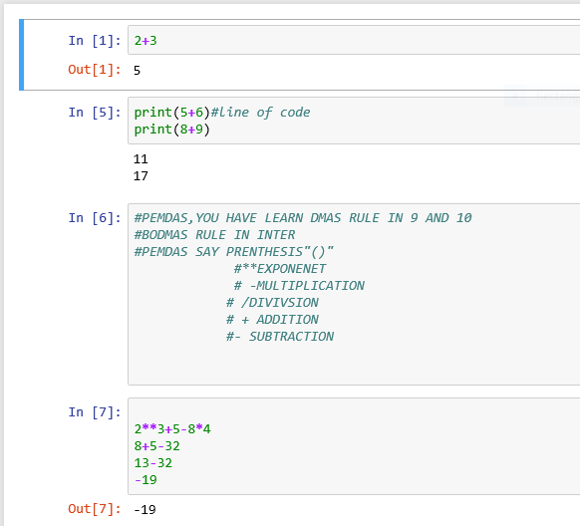

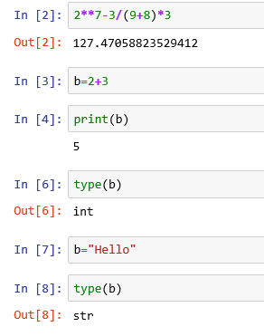

**TASK:**

Print biodata and arithmetic operations.